AI Assisted Coding
Assignment -1
Roll no : 2303A510C8
Task 0 : Install and configure GitHub Copilot in VS Code. Take screenshots of
each step.
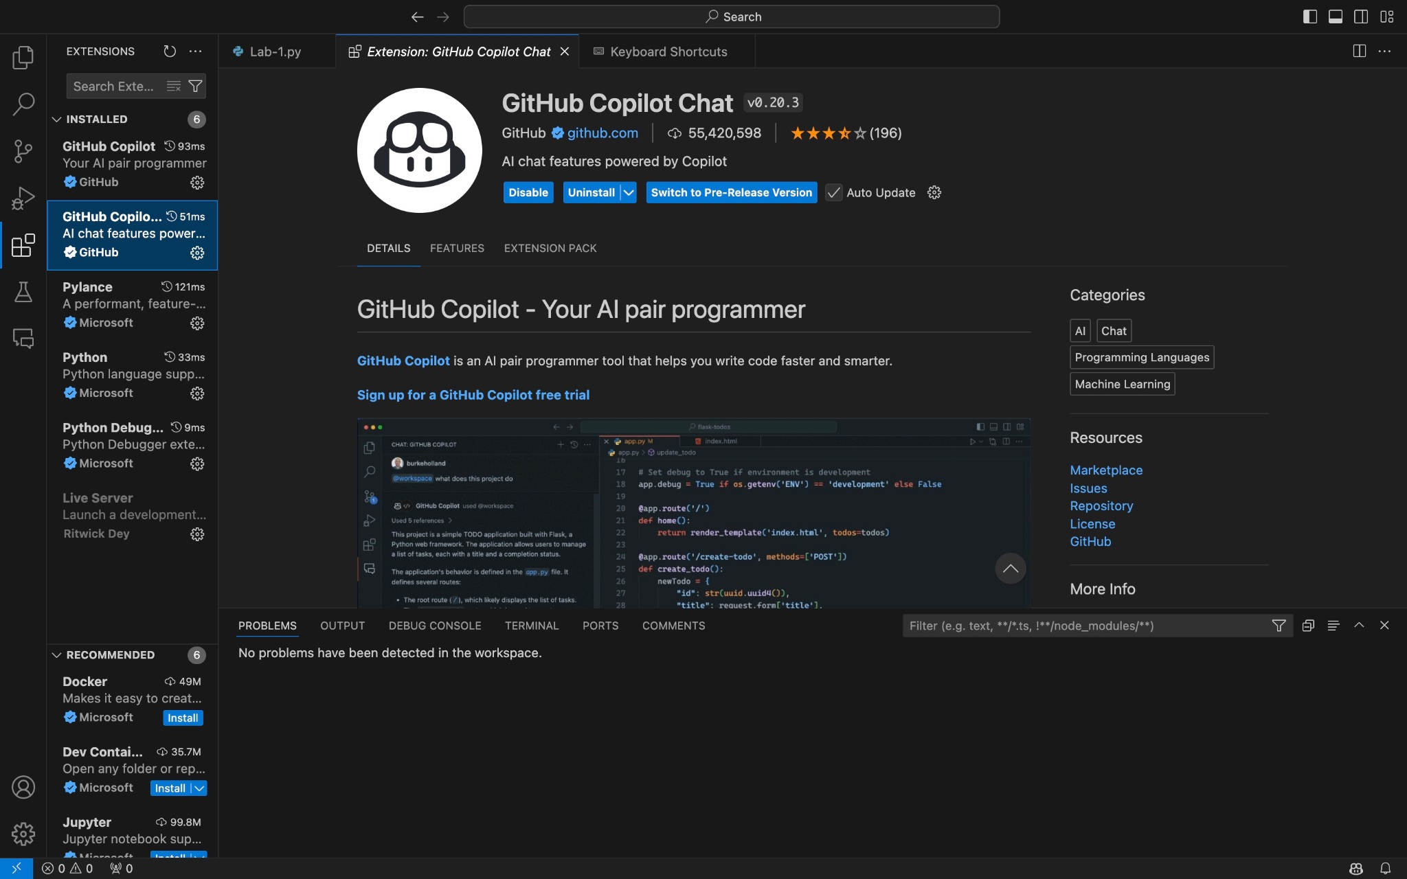
Task 1: AI-Generated Logic Without Modularization (Fibonacci Sequence
Without Functions)

# Write a Python program that accepts user input for 'n' and prints the Fibonacci sequence up to n terms using a loop. Do not use any functions.
# Accept user input for 'n'
n = int(input("Enter the number of terms in the Fibonacci sequence: "))
# Initialize the first two terms of the Fibonacci sequence
a, b = 0, 1
# Print the Fibonacci sequence up to n terms
for _ in range(n):
print(a, end=' ')
a, b = b, a + b
print() # For a new line after the sequence

Output:
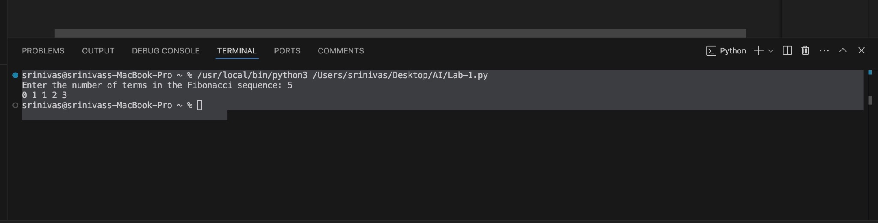

Explanation
- Initialization:
  - The program begins by initializing the first two terms of the Fibonacci sequence: t1 = 0 and t2 = 1.
  - A counter variable count is set to 0 to track how many numbers have been printed.
- Input Handling:
  - The user inputs an integer n (the number of terms required).
- Conditional Logic (if-elif-else):
  - The code first validates the input. If n <= 0, it prompts for a positive integer.
  - If n == 1, it handles the edge case by printing only the first term.

Task 2: AI Code Optimization & Cleanup (Improving Efficiency)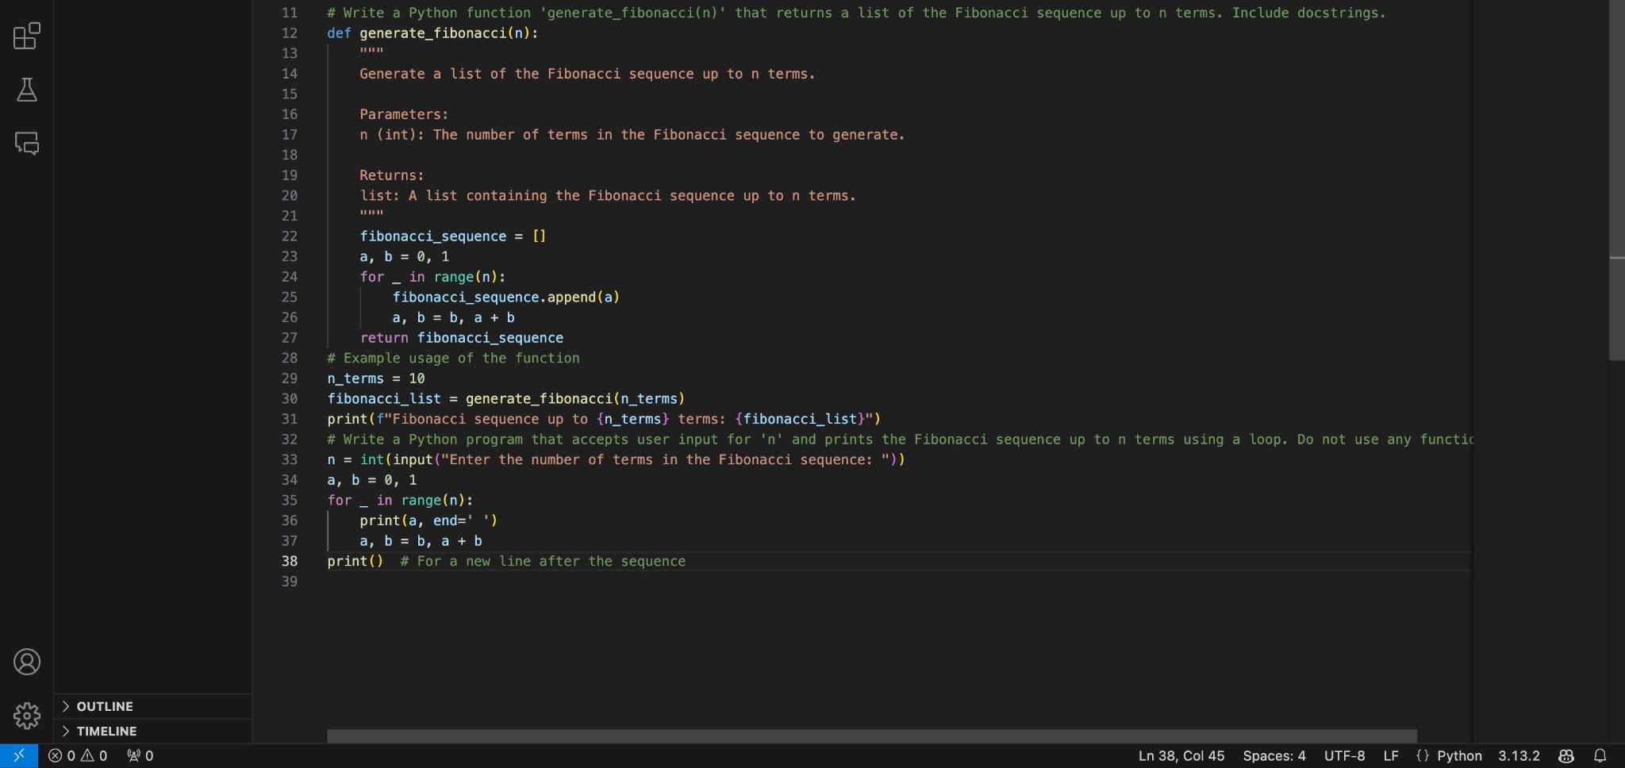
Output:
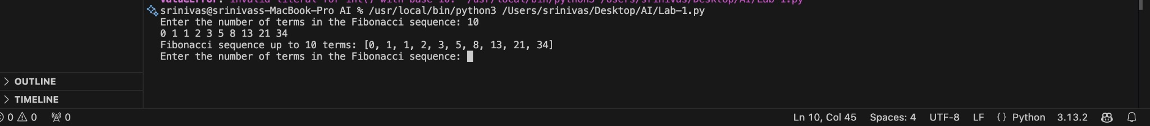
Explanation:
Tuple Unpacking: We replaced nth = t1 + t2, t1 = t2, t2 = nth with a, b = b, a + b. This removes the need for a temporary variable and reduces memory usage.
For Loop vs While Loop: A for loop using range(n) is generally more readable and less prone to infinite loop errors than a manually incremented while loop.
Variable Naming: Changed t1/t2 to standard a/b for mathematical clarity.

Task 3: Modular Design Using AI Assistance (Fibonacci Using Functions)
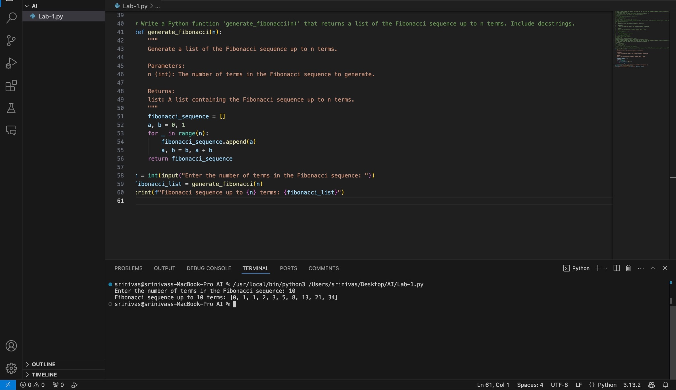
Explanation:
Function Definition (def):
- We define a function named generate_fibonacci(n). It takes one parameter (n), which represents the number of terms needed.
Docstring (AI-Assisted):
- The text inside the triple quotes ("""...""") is the docstring. It explains what the function does, the arguments it accepts, and what it returns. This is standard practice for readable code.
Task 4: Comparative Analysis – Procedural vs Modular Fibonacci Code

Feature | Task 1: No Functions (Procedural) | Task 3: With Functions (Modular)
Code Clarity | Logic is mixed with input/output. Harder to read as code grows. | Logic is isolated. The main block is clean and easy to read.
Reusability | Low. You must copy-paste the loop to use it elsewhere. | High. You can import this function into any other Python file.
Debugging | Harder. Variables are global; changes affect the whole script. | Easier. You can test the function in isolation with different inputs.
Suitability | Suitable only for quick, one-off scripts. | Essential for large systems and professional development.

Task 5: AI-Generated Iterative vs Recursive Fibonacci Approaches (Different
Algorithmic Approaches for Fibonacci Series)
# Generate two Python functions: one for Iterative Fibonacci and one for Recursive Fibonacci.
def iterative_fibonacci(n):
"""
Generate a list of the Fibonacci sequence up to n terms using an iterative approach.

Parameters:
n (int): The number of terms in the Fibonacci sequence to generate.

Returns:
list: A list containing the Fibonacci sequence up to n terms.
"""
fibonacci_sequence = []
a, b = 0, 1
for _ in range(n):
fibonacci_sequence.append(a)
a, b = b, a + b
return fibonacci_sequence
def recursive_fibonacci(n):
"""
Generate a list of the Fibonacci sequence up to n terms using a recursive approach.
Parameters:
n (int): The number of terms in the Fibonacci sequence to generate.
Returns:
list: A list containing the Fibonacci sequence up to n terms.
"""
if n <= 0:
return []
elif n == 1:
return [0]
elif n == 2:
return [0, 1]
else:
seq = recursive_fibonacci(n - 1)
seq.append(seq[-1] + seq[-2])
return seq

n = int(input("Enter the number of terms in the Fibonacci sequence: "))
iterative_result = iterative_fibonacci(n)
recursive_result = recursive_fibonacci(n)
print(f"Iterative Fibonacci sequence up to {n} terms: {iterative_result}")
print(f"Recursive Fibonacci sequence up to {n} terms: {recursive_result}")

Output:
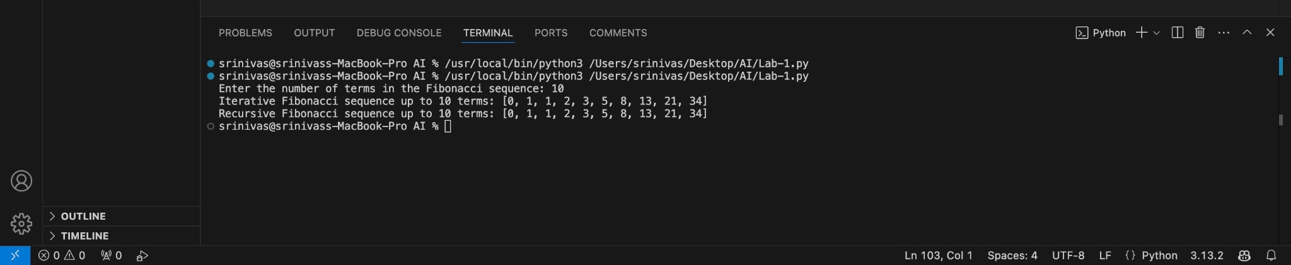
Explanation:
Iterative Approach:
- Time Complexity: O(n) (Linear). It calculates each number exactly once.
- Space Complexity: O(1) (Constant). It only stores two variables (a and b).
- Performance: Very fast, even for large numbers (e.g., n=1000).
Recursive Approach:
- Time Complexity: O(2n) (Exponential). It recalculates the same values multiple times (e.g., to calculate F(5), it calculates F(3) twice).
- Space Complexity: O(n) due to the "Call Stack" memory used by function calls.
- Performance: Very slow for large n. If n>40, the program may freeze or crash due to "Stack Overflow."

